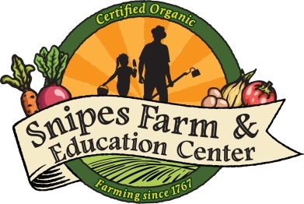
501(c)(3) nonprofit organization
www.snipesfarm.org
Sustainable farming Building community Reconnecting people to the land

Counselor in Training Application
Completed applications can be emailed to melanieds@snipesfarm.org

Name: Age:

Grade entering in Fall of 2020:

Address:

Phone Number:

Email:

What motivates or excites you to apply to the CIT program?

What skills would you bring to the program?

What skills do you want to gain or improve through your participation?

What is your availability this summer? Can you commit to 2-4 weeks at Snipes Farm Day Camp?

