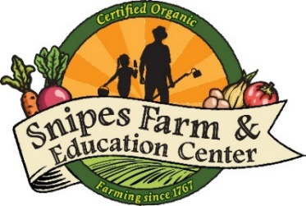
Application for Financial Aid for Snipes Farm Day Camp

For financial eligibility for scholarship aid please attach a copy of 2022 approved National Free School Lunch Program and/or your current tax return that shows adjusted gross income to the email in addition to the form below.
If not able to meet financial eligibility, there are additional circumstances which can be taken into consideration for at least a partial scholarship when describing your need below.
Please submit this form and if applicable the required document(s) to Camp Director, Melanie Douty-Snipes at MelanieDS@snipesfarm.org. Thank you for your application.

Contact Information

Parent/Guardian Applicant Name

Address

City, State, Zip

Email Address

Phone Number

Name of Camper

Camper Age

Grade Entering in Fall 2021

Camper Address

Camper City, State, Zip
Please share your need at this time:

