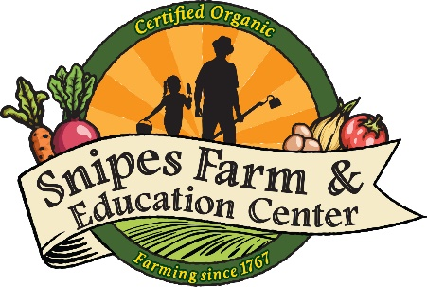
Application for Financial Aid for Snipes Farm Day Camp

Please fill out the form below and email to Camp Director, Melanie Douty-Snipes at MelanieDS@snipesfarm.org. After reviewing your application, Melanie will contact each applicant with the next steps. In addition to this form, please submit a letter describing your circumstance, describing your need and a copy of 2018-2019 approved National Free School Lunch Program and/or your current tax return that shows adjusted gross income.

Contact Information

Parent/Guardian Applicant Name

Address

City, State, Zip

Email Address

Phone Number

Name of Camper

Camper Age

Grade Entering in Fall 2018

Camper Address

Camper City, State, Zip

Please indicate which camp weeks you would like to register your camper, and whether your camper will be Full Time or Part Time.

Week 1: June 24 - June 28

Week 2: July 1 – July 5

Week 3: July 8 – July 12

Week 4: July 15 – July 19

Week 5: July 22 – July 26
Week 6: July 29 – August 2

Week 7: August 5 – August 9

Week 8: August 12 – August 16

Week 9: August 19 – August 23

Full Time (Monday – Friday, 8:30am – 3:30pm)

Part Time (Please indicate days your child will attend camp)

