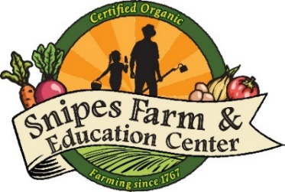
Application for Financial Aid for Snipes Farm Day Camp

Please fill out the form below and email to Camp Director, Melanie Douty-Snipes at MelanieDS@snipesfarm.org. After reviewing your application, Melanie will contact each applicant with the next steps. In addition to this form, please submit a letter describing your circumstance, describing your need and a copy of 2019-2020 approved National Free School Lunch Program and/or your current tax return that shows adjusted gross income.

Contact Information

Parent/Guardian Applicant Name

Address

City, State, Zip

Email Address

Phone Number

Name of Camper

Camper Age

Grade Entering in Fall 2019

Camper Address

Camper City, State, Zip

Please indicate which camp weeks you would like to register your camper, and whether your camper will be Full Time or Part Time.

We can guarantee two weeks of camp for each scholarship recipient at this time. We will reevaluate our scholarship fund in June and reach out to families if we can offer additional weeks of camp at that time.

Week 1: June 22 - June 26

Week 2: June 29 – July 3

Week 3: July 6 – July 10

Week 4: July 13 – July 17

Week 5: July 20 – July 24
Week 6: July 27 – July 31

Week 7: August 3 – August 7

Week 8: August 10 – August 14

Week 9: August 17 – August 21

Full Time (Monday – Friday, 8:30am – 4:00pm)

Part Time (Please indicate days your child will attend camp)

