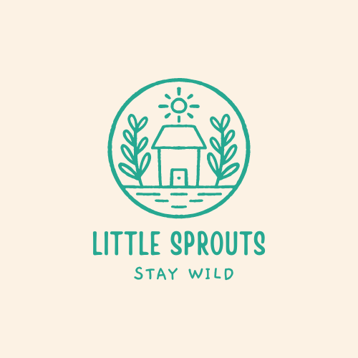
Dear Friends of Little Sprouts,

Thank you so much for your love and support of our Little Sprouts Program. We did not expect our “little engine that could” program to take off so quickly! Snipes Farm and Education Center is a 501(c) non profit. Any donations made are tax deductible as we are a 501(c), tax exempt nonprofit organization. Donation receipts are available to anyone that would like one.

We LOVE used, hand-me-down items! Some items listed may just be sitting around your home.
Thank you for your support of our program.
Stay Wild!

,
Nicole

- Scrap Wood, all different sizes, free of nails
- 8oz Stubby Claw Hammer, 15 are needed
- Kids Green Wheelbarrow, WHO0201, Tractor Supply, $19.99, 10 are needed
- Mud Kitchen Supplies, Utensils, bowls, small pitchers, muffin tins, tea cups, small pots and pans. Used or purchased from a thrift store.
- Rocks of different sizes, to be used decoratively as well as for play. Think landscaping rocks, from medium to gravel sized. Some will be used for painting, the smaller rocks will be for our rock garden play space.
- Porch swing and stand (can be purchased or built)

- Hose reel with wheels
- 100 feet heavy duty hose
- Wheelbarrows, old ones to be used as garden beds
- Veggie Peelers, Ikea, dollar store, thrift store or used , 20 are needed
- 1 inch roofing nails with larger hammer surface, no plastic tops please
- Hand tools, screwdrivers, levels, hand drills, no need to buy new
- Kids sized garden tools, non-plastic please, they break very easily.
- Dry beans, boxes of pasta
- Play Dough
- Do a Dot or Bingo dotters
- Rubber stamps, new or used
- cardstock
- ANY AND ALL Craft supplies, if you’re getting rid of any, we’ll find a use for them

- Organic soil

- Silky feeling scarves, all colors and sizes
- Windchimes

- 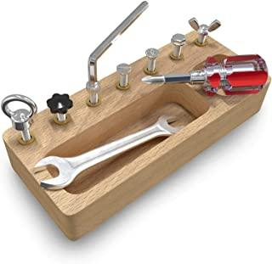Screwdriver Board Set, can be purchased or homemade
- Native plants and seeds
- Corn Starch
- Baking Soda
- Vinegar
- Bird Seed
- Food Coloring
- Uncooked Rice
- Craft Paper, color and white
- Paper easel pad
- Thick/wide markers
- Liquid Gel Glue
- Large and X Large Binder Clips
- Washable Paint, Watercolor Paint, finger paint
- Craft Paint Brushes
- Gift cards to Home Depot, Lowes, Amazon, Local Garden Centers

We love volunteers! Any friends with construction or building skills would be greatly appreciated. We have some medium sized projects that could use some helping hands. We would also love for our friends with gardening skills to be able to assist us in setting up our gardens. Little Sprouts is also beginning an adoptive grandparent program to anyone that would love to lend their talents in crafts, helping parents with multiple children during class and many other aspects of Little Sprouts. Anyone participating directly with children will need to present a background screening. Please reach out to littlesproutsnicole@gmail.com with any questions or for more information.

